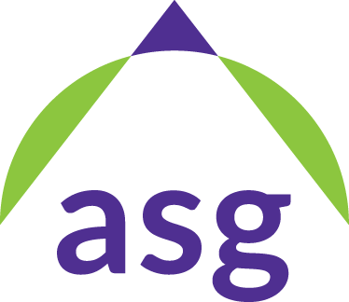

Northwestern University

Associated Student Government

Meeting of the Senate

January, 7, 2014

1. **Call to Order and Roll Call**
2. **Approval of the Journal:** Available at [bit.ly/ASG-Senate-Minutes](http://bit.ly/ASG-Senate-Minutes).
3. [**Executive Board Reports**](https://docs.google.com/document/d/1JqyQa6VJNvV5VvoqRkYt_z-TilYz9lf30r7b9g8CFiI/edit#bookmark=kix.1tx6i3ka0ej8)
4. **General Order:** Wild Ideas PR Rush

* Andrew: We would really love for more people to apply for Wild Ideas. If you could tweet out or post a status of the application link (bit.ly/nuwildideas) If you represent a student group, then let them know! It’s a great way to try out a new event.

1. **General Order**: ABTS Volunteers ([sign up form](https://docs.google.com/a/u.northwestern.edu/forms/d/1IqYbCw5woD_osg862w-yE_6r71McDJ9CXZ0wcbOuQUY/viewform))

* Chris: Erik talked a bit about ABTS. First check out Kevin or my exec board report for more details. Next week we have Big Ten representatives coming, so we need volunteers to help out. We only need about 4-6 volunteers and it will only be a few hours unless you’re interested in more. Maybe be a bus captain or checking people into the hotel. It’ll be pretty fun so please sign up!

1. **General Order:** Student Life Committee Focus: [University Committees](https://docs.google.com/a/u.northwestern.edu/presentation/d/1drVznkgktliiI16qWsaGiXIYfIjHd8BplFJGIYEjJ0k/edit?usp=sharing)

* Chris: Just because we have a little bit of time, I want to take a few minutes to tell you about what Student Life does and where we represent students on official committees. Our job is to provide the student perspective to administrators and faculty, which is a difficult job. I’d love for you to reach out to me if you’re interested in any of these committees and I can bring you along. It is an opportunity for our committee to get more of a perspective.

1. **SL1415-09:** [Accessibility: Updating Vocabulary](https://docs.google.com/document/d/1JqyQa6VJNvV5VvoqRkYt_z-TilYz9lf30r7b9g8CFiI/edit#bookmark=id.s406ravryeau)

* Austin: Basically what I want to present are some updates to the committee. We spent a lot of time reflecting internally about our mission and vision statement, which you can read in the legislation. We realized there was a bit of a disconnect, especially with the word diversity. We need to make sure that the community is accessible and inclusive and in that way it can be more diverse. There are three things. The first is a code change, just switching out “Accessibility” for “Diversity.” We are still trying to foster diversity, but it makes more sense to do that through accessibility. The second and third parts are just about logistics: changing my email and changing the PR plan. Once this legislation passes, all future communication would include the new name. We are trying to do that within the next year. It’s not drastic, but just trying to make sure we’re aligning to our vision and mission.

1. **Roll Call and Adjournment**